RIHAM AHAMED ABDUL RAHEEM

HND COMPUTING IDM

Discrete Maths

Contents

**ACKNOWLEDGEMENT** 1

**PART1** 2

A. 2

**Question 1** 2

**Question 1 Answer** 2

**Question 2** 4

B. 5

**Question 1** 5

**Question 1 Answer** 5

C. 6

**Question 1** 6

**Question 2** 7

**PART2** 8

A. 8

B. 10

C. 10

**PART3** 11

**PART4** 12

References 14

**List of figure**

Figure 1: Degree sequence diagram 10

**List of tables**

Table 1: Graph R and F vertices and edge compression table 8

Table 2: Graph R edge connectivity letter compression table 9

Table 3: Graph F edge connectivity letter compression table 9

# **ACKNOWLEDGEMENT**

We are really grateful because we managed to complete our **Discrete Maths** assignment within the time given by our lecturer **Mr. Kumanan** this assignment cannot be completed without the effort and co-operation from our lecturer. So I sincerely thank our lecturer of **Discrete Maths** for the guidance and encouragement in finishing this assignment and also for teaching us in the course. Last but not least, we would like to express our gratitude to our friends and respondents for the support and willingness to spend some times with us to fill in the questionnaires.

# **PART1**

## A.

### **Question 1**

$\left(\overline{a}.\overline{b}+c\right)\left(a+b\right)\left(\overline{\overline{b}+ac}\right)=cb(a+b)(\overline{a}+\overline{c})$

### **Question 1 Answer**

L.H.S

$$R=(\overline{a}.\overline{b}+c)(a+b)(\overline{\overline{b}+ac})$$

Apply de Morgan's theorem $a.b=\overline{\overline{a}+\overline{b}}$

R = $(\overline{\overline{\overline{a}}+\overline{\overline{b}}}+c)(a+b)(\overline{\overline{b}+ac})$

Apply the double negation (involution) law $\overline{\overline{a}}=a$

$$R =(\overline{a+b}+c)(a+b)(\overline{\overline{b}+ac})$$

Apply the commutative law

$$R =(a+b)(\overline{a+b}+c)(\overline{\overline{b}+ac})$$

Apply the redundancy law $a\left(\overline{a}+b\right)=a.b$

$$R = ((a+b).c)(\overline{\overline{b}+ac})$$

Apply de Morgan's theorem $\overline{a+b}=\overline{a}.\overline{b}$

$$R = ((a+b).c)(\overline{\overline{b}}.\overline{ac})$$

Apply the commutative law

$$R =(b.\left(b+a\right).c.\overline{a.c}$$

Apply the absorption law $a.\left(a+b\right)=a$

$$R =b.c.\overline{a.c}$$

Apply de Morgan's theorem $\overline{a.b}= \overline{a}+\overline{b}$

$$R = b.c.(\overline{a}+\overline{c})$$

Apply the redundancy law $a\left(\overline{a}+b\right)=a.b$

R = $b.c.\overline{a}$

L.H.S Answer = $b.c.\overline{a}$

R.H.S

$$F=cb(a+b)(\overline{a}+\overline{c})$$

Apply the absorption law $a.\left(a+b\right)=a$

$$F=c.b(\overline{a}+\overline{c})$$

Apply the commutative law

$$F=c.\left(\overline{c}+\overline{a}\right).b$$

Apply the redundancy law $a\left(\overline{a}+b\right)=a.b$

$$F=c.\left(\overline{a}\right).b$$

Apply the commutative law

$$F=b.c.\overline{a}$$

R.H.S Answer = $b.c.\overline{a}$

∴ L.H.S = R.H.S

### **Question 2**

$R=\left(\overline{\overline{AB}+\overline{A}+AB}\right)=0$

**Question 2 Answer**

Apply the commutative law

$$R=\left(\overline{\left(AB\right)+\overline{AB}+\overline{A}}\right)$$

Apply the complement law $A+\overline{A}=1$

$$R=\left(\overline{1+\overline{A}}\right)$$

Apply the commutative law

$$R=\left(\overline{\overline{A}+1}\right)$$

Apply the dominant (null, annulment) law $A+1=1$

$$R=\left(\overline{1}\right)$$

Apply negation law $\overline{1}=0$

$$R=\left(0\right)$$

∴ Answer is 0

## B.

### **Question 1**

$Y=\overline{AC}+B\overline{C}+ABC$

### **Question 1 Answer**

Apply de Morgan's theorem $\overline{a.b}= \overline{a}+\overline{b}$

$$Y =\left(\overline{A}+\overline{C}\right)+\left(B.\overline{C}\right)+(A.B.C)$$

Apply the commutative law

$$Y =\overline{A}+\overline{C}+\left(\overline{C}.B\right)+(A.B.C)$$

Apply the absorption law $a.\left(a+b\right)=a$

$$Y =\overline{A}+\overline{C}+(A.B.C)$$

Apply the commutative law

$$Y =\overline{A}+\left(A.B.C\right)+\overline{C}$$

Apply the redundancy law $a\left(\overline{a}+b\right)=a.b$

$$Y =\overline{A}+\left(B.C\right)+\overline{C}$$

Apply the commutative law

$$Y =\overline{A}+\overline{C}(C.B)$$

Apply the redundancy law $a\left(\overline{a}+b\right)=a.b$

$$Y =\overline{A}+\overline{C}+B$$

A

C

B

## C.

### **Question 1**

$$f:R-\{-4\}→R$$

So $f\left(x\right)=4x$

1

2

3

1

2

3

4

5

6

7

8

9

10

11

12

Domain: {1,2,3}

Co domain: {1,2,3,4,5,6,7,8,9,10,11,12}

Range: {4,8,12}

**Domain and Range** values are equal So this function is **One to One function.**

### **Question 2**

$$f\left(x\right)=\frac{\left(x-3\right)}{(x+4)}$$

$$f^{'}\left(x\right)=-\frac{\left(x-3\right)}{{\left(x+4\right)}^{2}}+ \frac{1}{(x+4)}$$

Assume $f^{'}\left(x\right)=0$

$$\frac{1}{(x+4)}= \frac{\left(x+3\right)}{{\left(x+4\right)}^{2}}$$

$\left(x+2\right)=(x+3)$ This is not possible

∴ Curve is not differentiable at any point.

So, this function is **One to One function**

# **PART2**

## A.

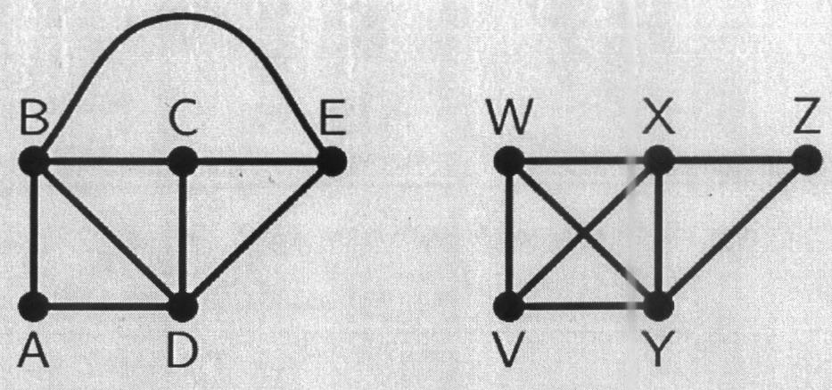

R

F

Assume the image R and F

A graph can exist in different shapes with the same number of vertices, edges, and also the same edge connectivity. These graphs are called isomorphic graphs. Note that we primarily name the images in this chapter to refer to them and identify them from one another.

Two graphs A and B are said to be isomorphic if –

* Their number of components (vertices and edges) are the same.
* Their edge connectivity is retained.

Note − In short, out of the two isomorphic graphs, one is a tweaked version of the other. An unlabeled graph also can be thought of as an isomorphic graph. (tutorialspoint, 2021)

1. If we look at the R and F graph above based on vertices and edges

Table : Graph R and F vertices and edge compression table

|  |  |
| --- | --- |
| Graph R | Graph F |
| Number of vertices | |
| 5 | 5 |
| Number of edges | |
| 8 | 8 |

So, first theory vertices and edges are same.

1. If we look at the R and F graph above based on edge connectivity

Table : Graph R edge connectivity letter compression table

|  |  |
| --- | --- |
| Edge connectivity letter | Graph R |
| A | 2 |
| B | 4 |
| C | 3 |
| D | 4 |
| E | 3 |

Table : Graph F edge connectivity letter compression table

|  |  |
| --- | --- |
| Edge connectivity letter | Graph R |
| A | 2 |
| B | 4 |
| C | 3 |
| D | 4 |
| E | 3 |

So, second theory edge connectivity are same.

1. If we look at the R and F graph above based on mapping

$f\left(A\right)=$ Z

$$f\left(B\right)=Y$$

$$f\left(C\right)=V$$

$$f\left(D\right)=X$$

$$f\left(E\right)=W$$

So, based on mapping also same.

In this regard Graph **R and F is isomorphic graphs.**

## B.

This graph is not a Euler circuit. Because, The Euler circuit must satisfy two rules on which basis it is not the Euler circuit.

The two rules are

* Euler circuit are satisfaction on Euler path; The Eulerian path is a trace on a finite graph that **visits each edge exactly once**.
* Second rule is Euler path stating edge and ending edge are same.

On that basis This graph is not a Euler circuit but this graph is Euler path graph.

Euler path of this graph: $AD →DC →CB →BD →DE →EB →BA →AC$ 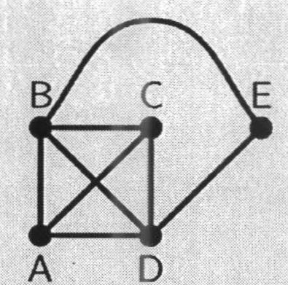

## C.

This graph cannot be draw.

A (6)

B (5)

C (4)

D (3)

E (2)

F (1)

G (1)

Reason:

Figure 1: Degree sequence diagram

* This diagram has 7 vertices; Vertices order {6,5,4,3,2,1,1}.
* On that basis **A** vertices contact in **6 edges.** (B:5, C:4, D:3, E:2, F:1, G:1)
* But **E vertices contact in 3 edges** and **F vertices contact in 2 edges**. So, Assume This graph in **not a Degree Sequence diagram.**

# **PART3**



|  |  |  |
| --- | --- | --- |
|  | Junior | Senior |
| Male | 100 | 80 |
| Female | 120 | 100 |



|  |  |  |  |
| --- | --- | --- | --- |
|  | Healthy | Sick | Carrier |
| Junior | 33 | 77 | 110 |
| Senior | 55 | 54 | 71 |

$${\left(\begin{matrix}33 & 77 & 110 \\ 55 & 54 & 81\end{matrix}\right)}_{2×3}$$

${\left(\begin{matrix}100 & 120 \\ 80 & 100\end{matrix}\right)}_{2×2} × {\left(\begin{matrix}33 & 77 & 110 \\ 55 & 54 & 71\end{matrix}\right)}_{2×3}$

$${\left(\begin{matrix}100×33+120×55 & 100×77+120×54 & 100×110+120×71 \\ 80×33+100×55 & 80×77+100×54 & 80×110+100×71\end{matrix}\right)}_{2×3}$$

$${\left( \begin{matrix}9900 & 14180 & 19520 \\ 8140 & 11560 & 15900\end{matrix}\right)}_{2×3}$$

# **PART4**

Children: $x$

Adult: $y$

I.

$$\frac{3}{2} x+4y=5050$$

$$x+y=2200$$

II.

$$\left(\begin{matrix}\frac{3}{2} & 4 \\ 1 & 1\end{matrix}\right) \left(\begin{matrix}x \\ y\end{matrix}\right)= \left(\begin{matrix}5050 \\ 2200\end{matrix}\right)$$

III.

$$A^{-1}= \frac{1}{\frac{3}{2}-4} \left(\begin{matrix}1 & -4 \\ -1 & \frac{3}{2}\end{matrix}\right)$$

$$A^{-1}= \frac{1}{-\frac{5}{2}} \left(\begin{matrix}1 & -4 \\ -1 & \frac{3}{2}\end{matrix}\right)$$

$$A^{-1}= -\frac{2}{5} \left(\begin{matrix}1 & -4 \\ -1 & \frac{3}{2}\end{matrix}\right)$$

$$A^{-1}= \left(\begin{matrix}-\frac{2}{5} & \frac{8}{5} \\ \frac{2}{5} & -\frac{3}{5}\end{matrix}\right)$$

$$AX=B$$

$$A^{-1}AX=A^{-1}B$$

$${IX= A}^{-1}B$$

$${X=A}^{-1}B$$

$$\left(\begin{matrix}x \\ y\end{matrix}\right)= \left(\begin{matrix}-\frac{2}{5} & \frac{8}{5} \\ \frac{2}{5} & -\frac{3}{5}\end{matrix}\right)\left(\begin{matrix}5050 \\ 2200\end{matrix}\right)$$

$$\left(\begin{matrix}x \\ y\end{matrix}\right)= \left(\begin{matrix}-2020 & +3520 \\ 2020 & -132\end{matrix}\right)$$

$$X=1500$$

$$X+Y=2200$$

**Y = 700**

# References

tutorialspoint, 2021. *Graph Theory - Isomorphism.* [Online]   
Available at: https://www.tutorialspoint.com/graph_theory/graph_theory_isomorphism.htm  
[Accessed 1 December 2021].